Lab 1: Motor 1 Efficiency Mapping
Line-by-line instructions
Run Lab_1_Setup.m.
The Host model opens first.
In the Host model, click the Target model link.
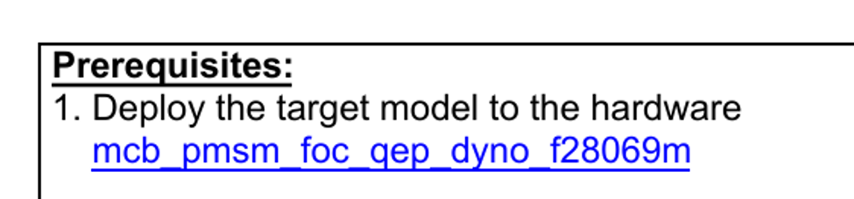
Figure 1: Target model link
In the new Target model window, not the Host model, click Build, Deploy, and Start.
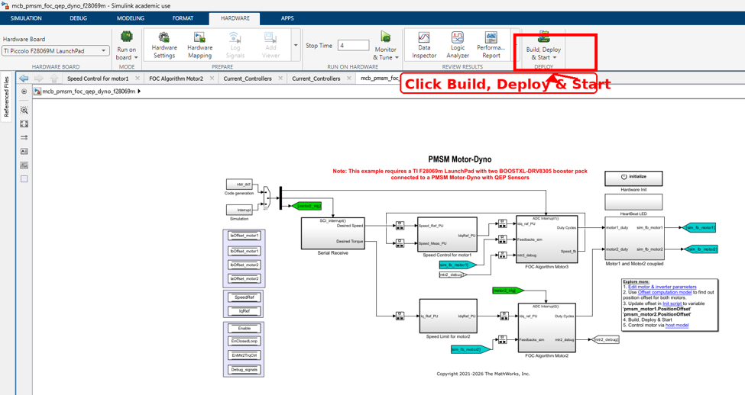
Figure 2: Build, Deploy, and Start in the new Target model window.
Once loaded, run the Host model.
Click the Motor1 switch to Start.
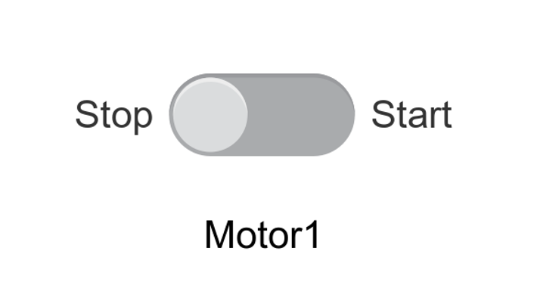
Figure 3: Motor1 switch.
Take data for the following trials using the debug selection tool:
Trial folder | Debug selector choice
trial01 | Mtr1: Speed reference & Speed feedback
trial02 | Mtr1: Iq reference & Iq feedback
trial03 | Mtr1: Vd & Vq
trial04 | Mtr1: Pm & Te

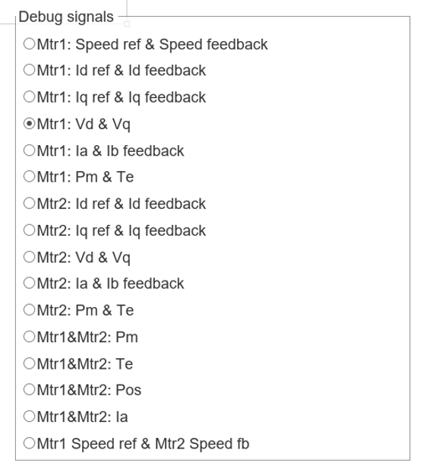
Figure 4: Debug Signal selection.

Once the trial ends, wait until the motor goes to near-zero speed.
Run save_debug_session.m.
Name the folder trial01, trial02, trial03, or trial04.

Once all data is saved, run data_processing.m.
View the generated figures.
If communication fails, select the correct COM port in Host Serial Setup, Host Serial Receive, and Host Serial Transmit.
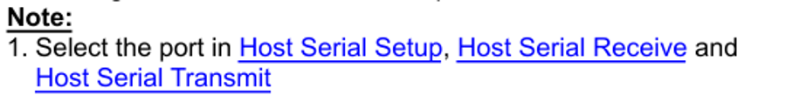
Figure 5: Host serial COM-port note.

